# Login screen

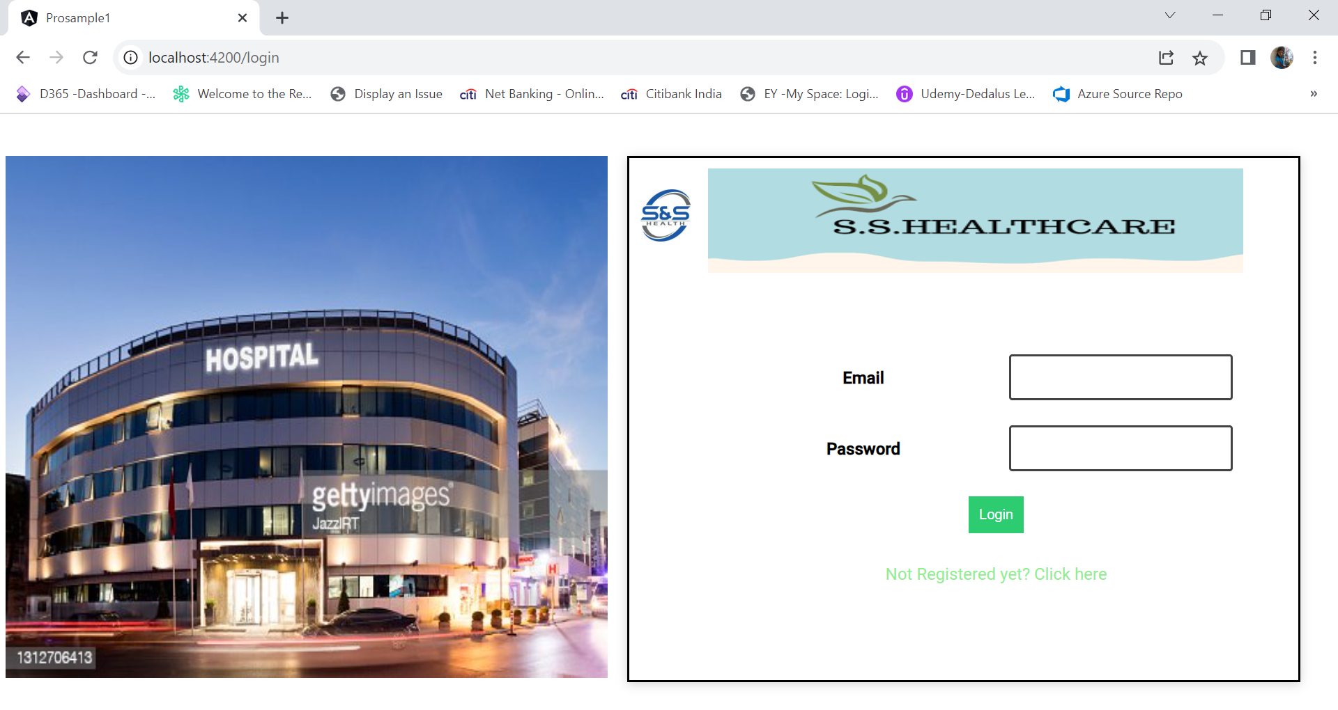

# Login registration/Signup screen

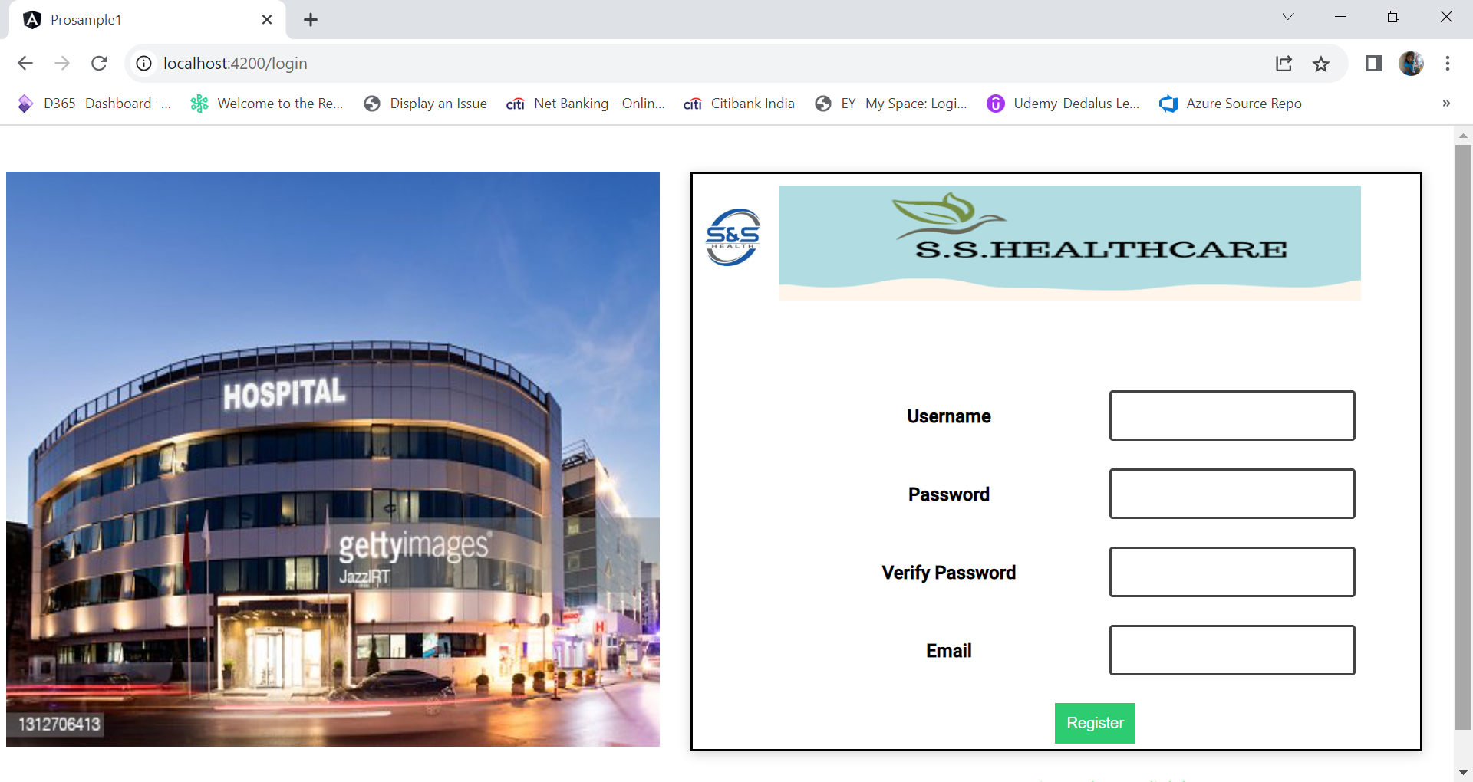

# Administer workflow.

## Login as administrator ([Rajan@gmail.com](mailto:Rajan@gmail.com))

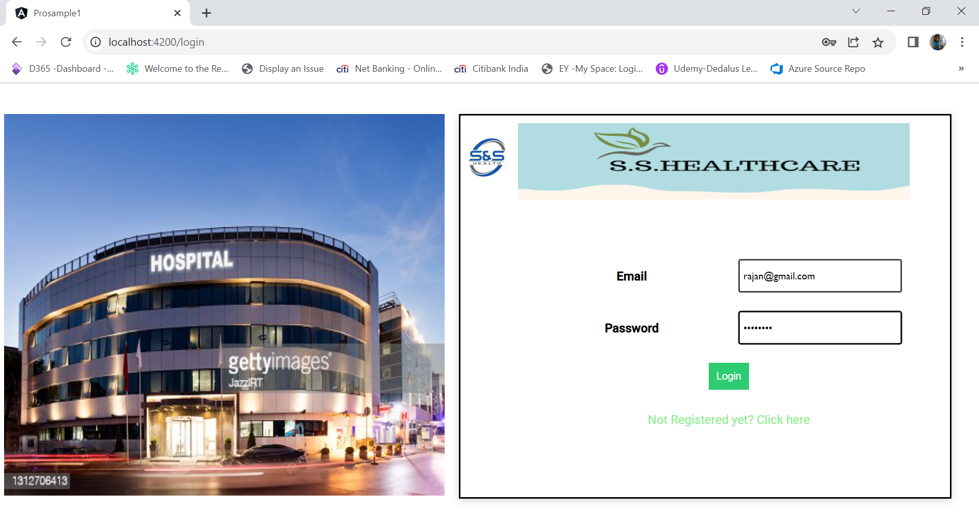

## Login Admin home page

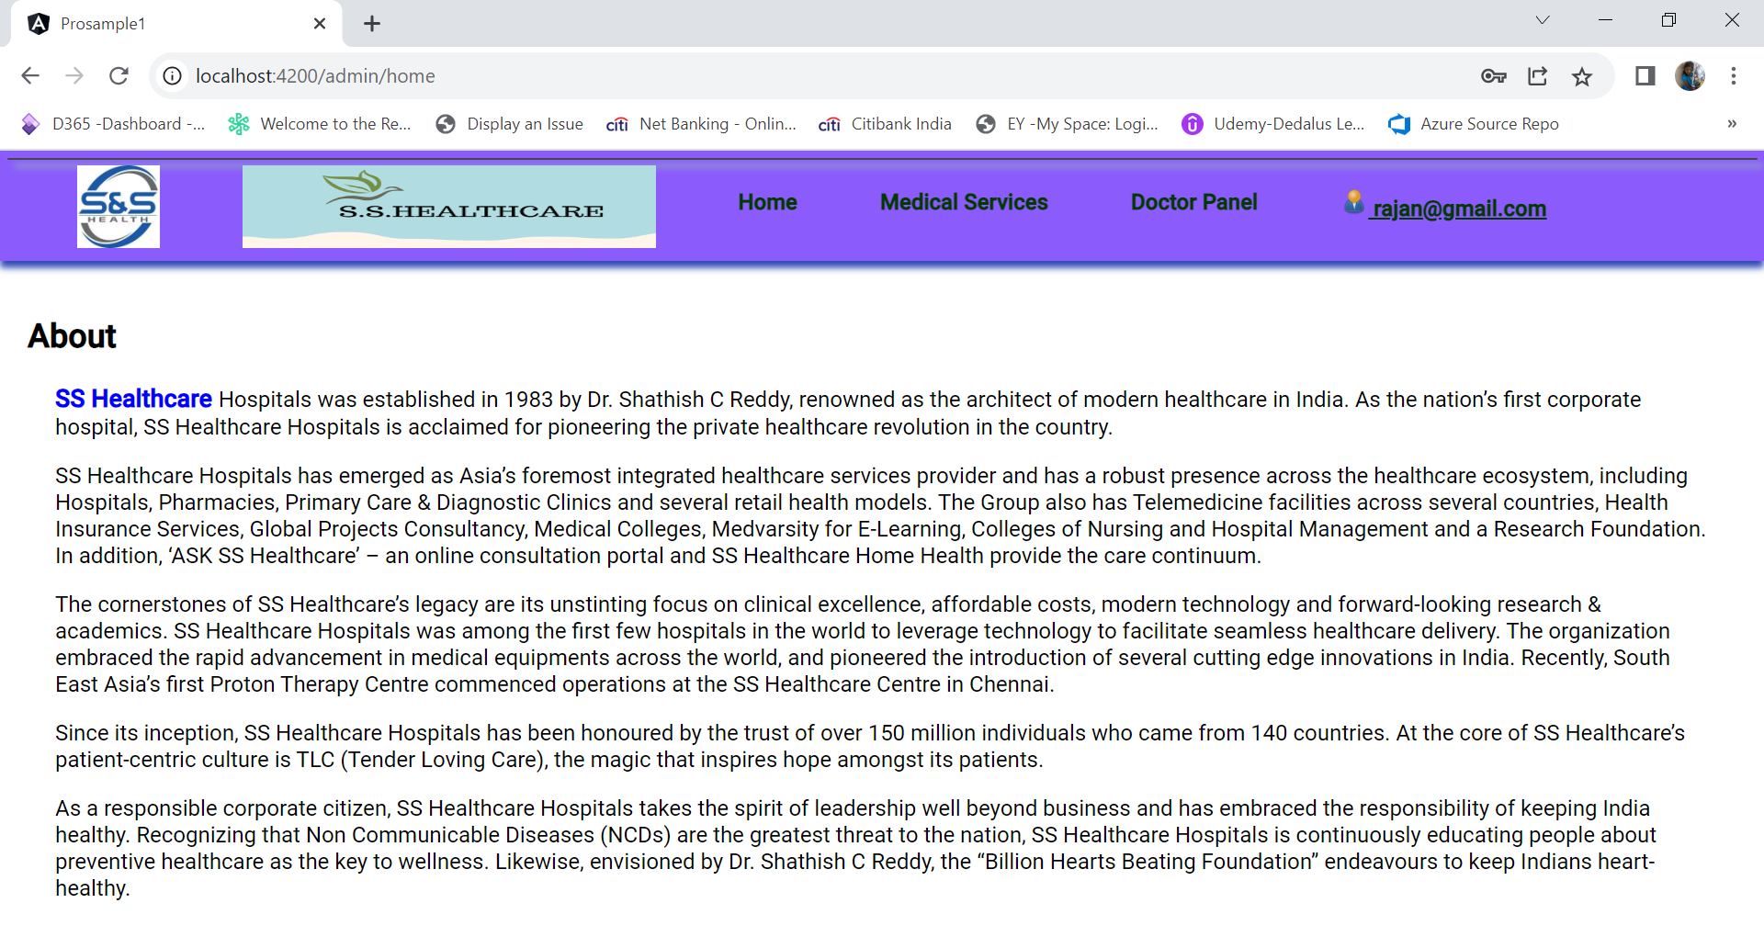

## Medical Service page

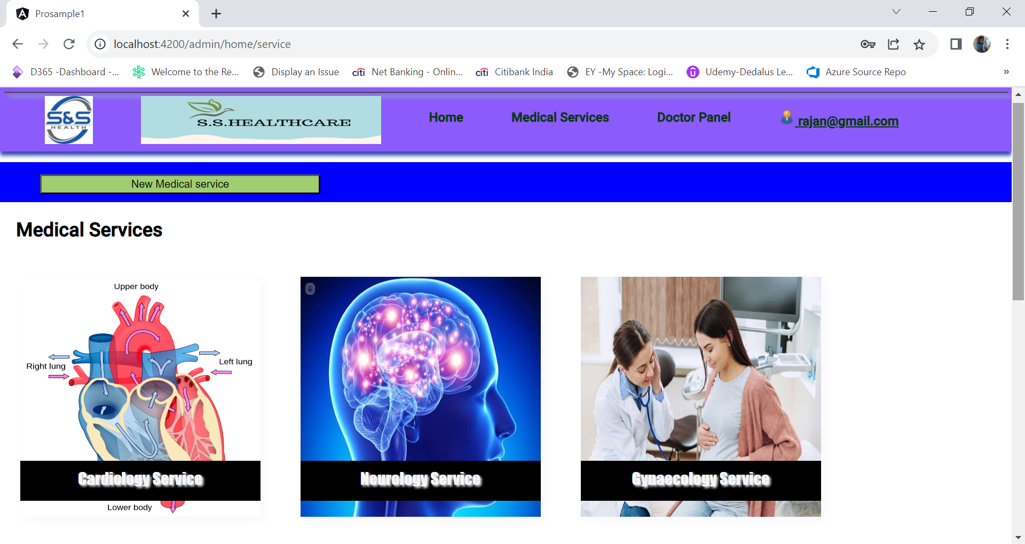

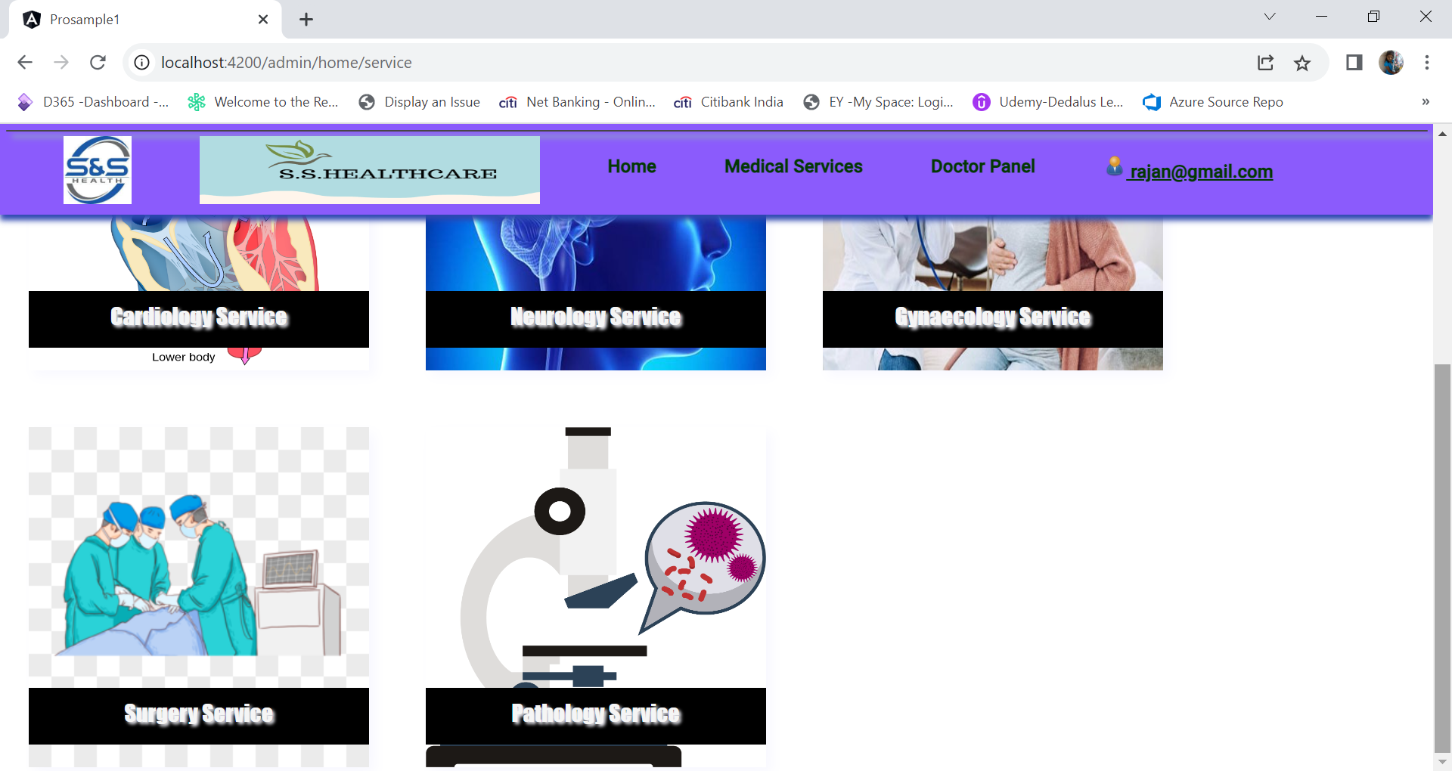

## Medical Service detail screen page

The detail medical service screen will be opened while clicking the images of the service.

New Medical Service button will be available only for the administrator login workflow.

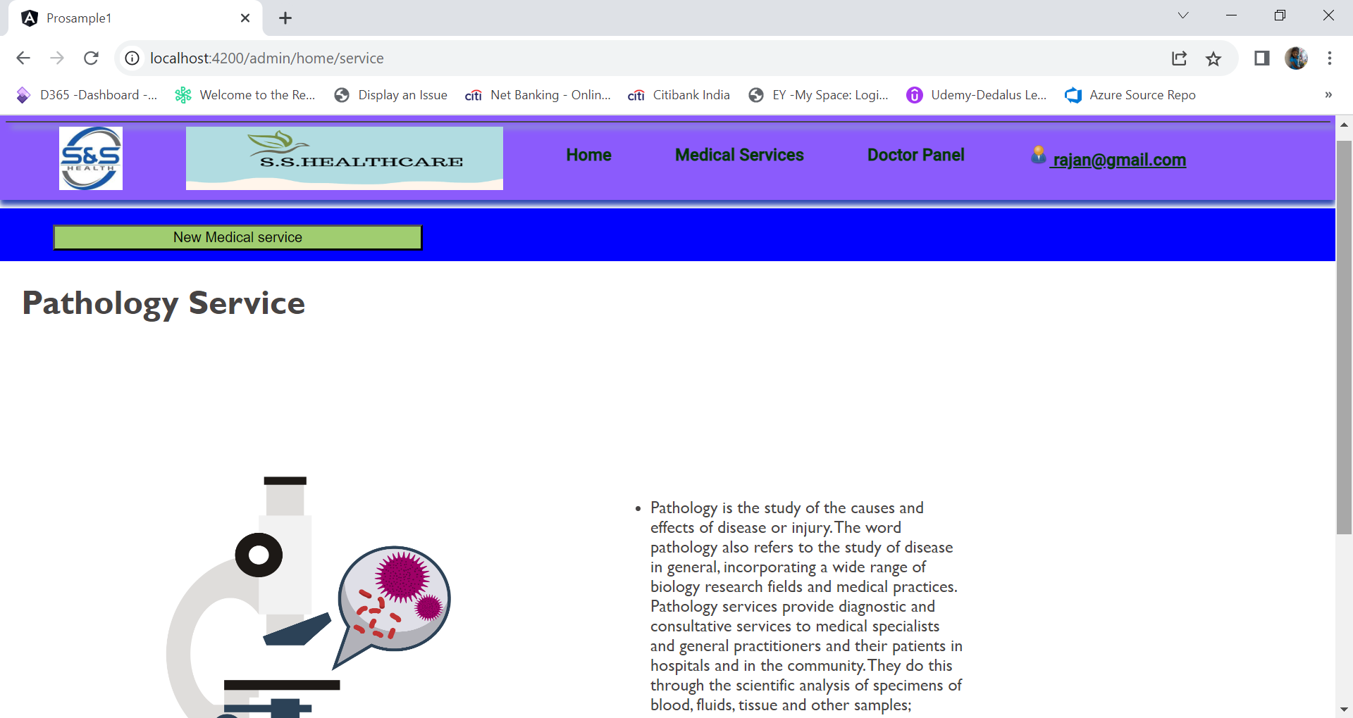

## New Medical Service creation screen

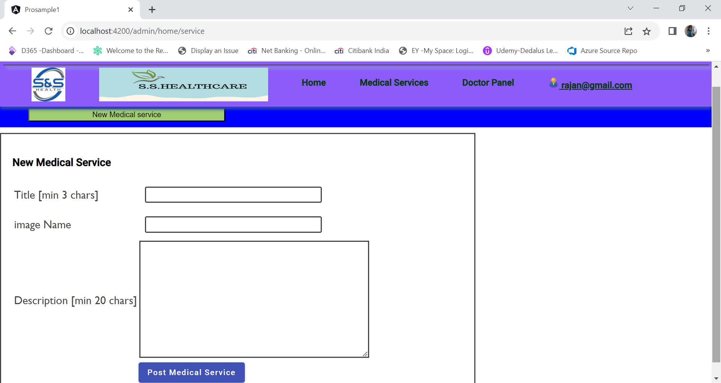

## Create a new medical service.

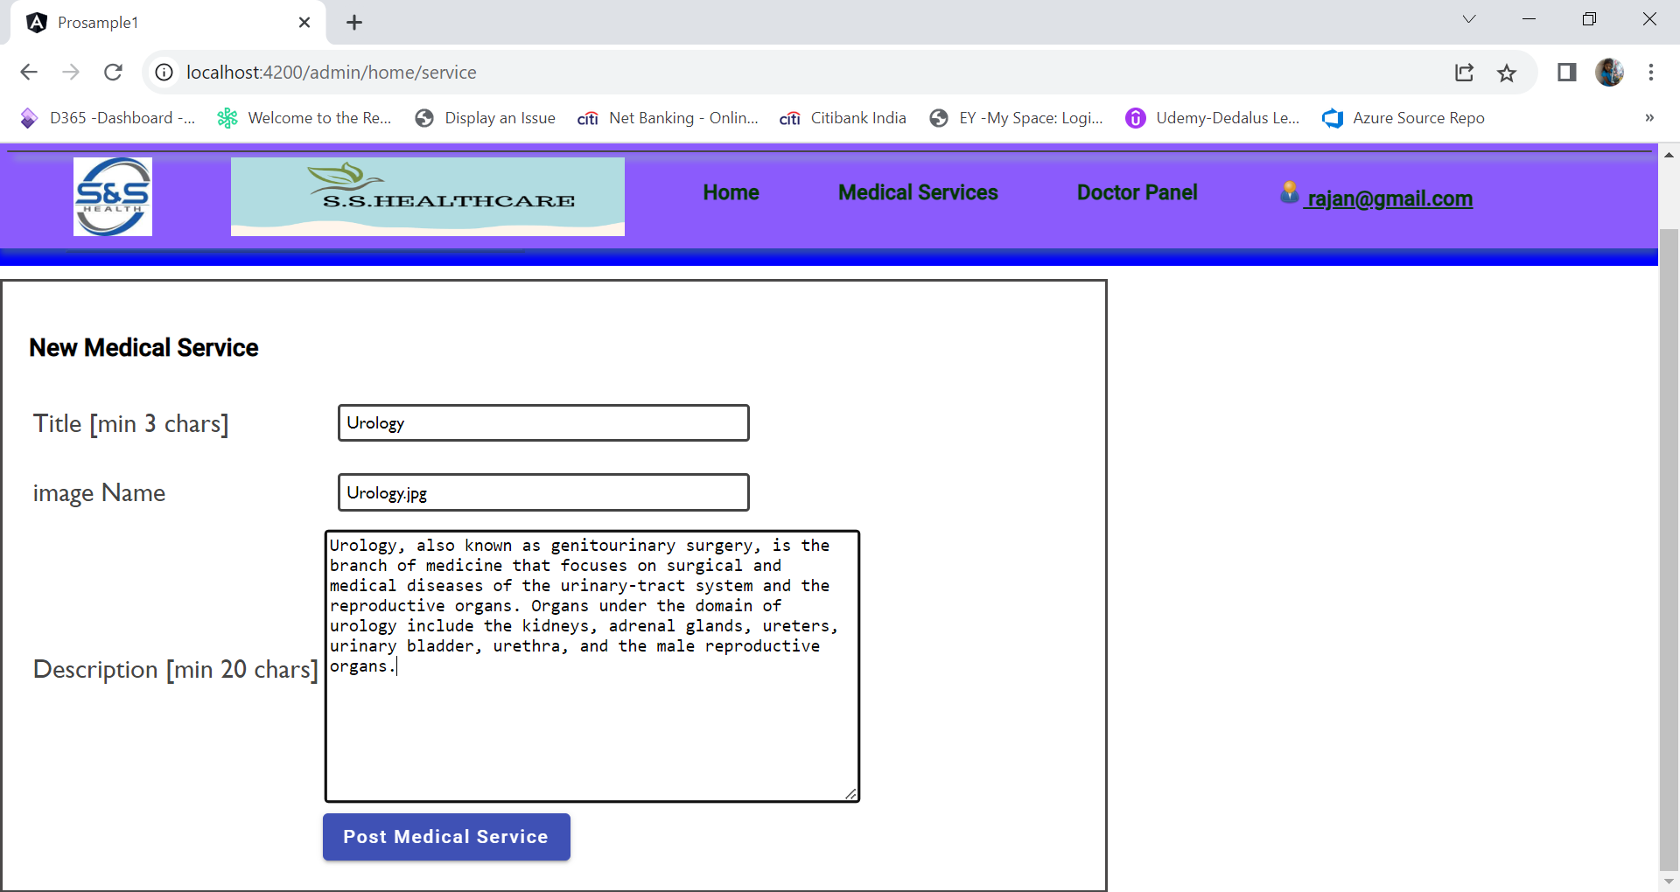

Click on Post Medical Service

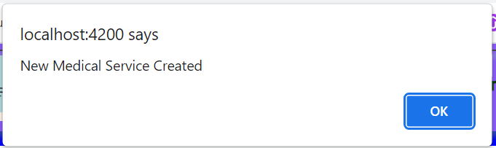

Click on Ok

## New Medical service displayed in Overview panel.

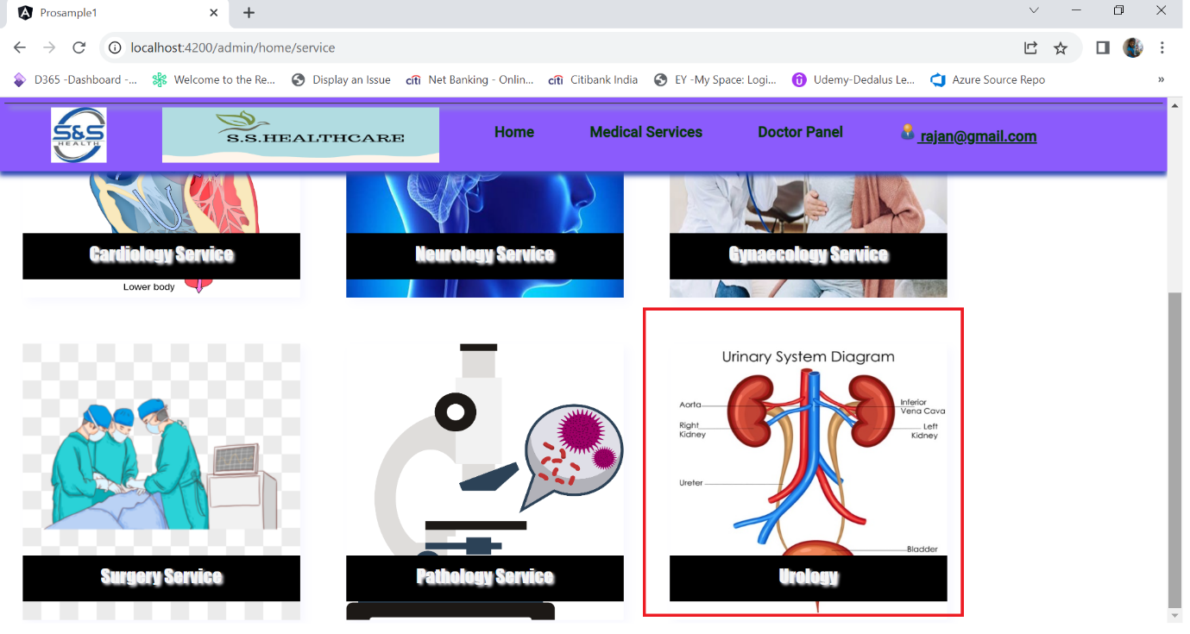

## Doctor List Panel.

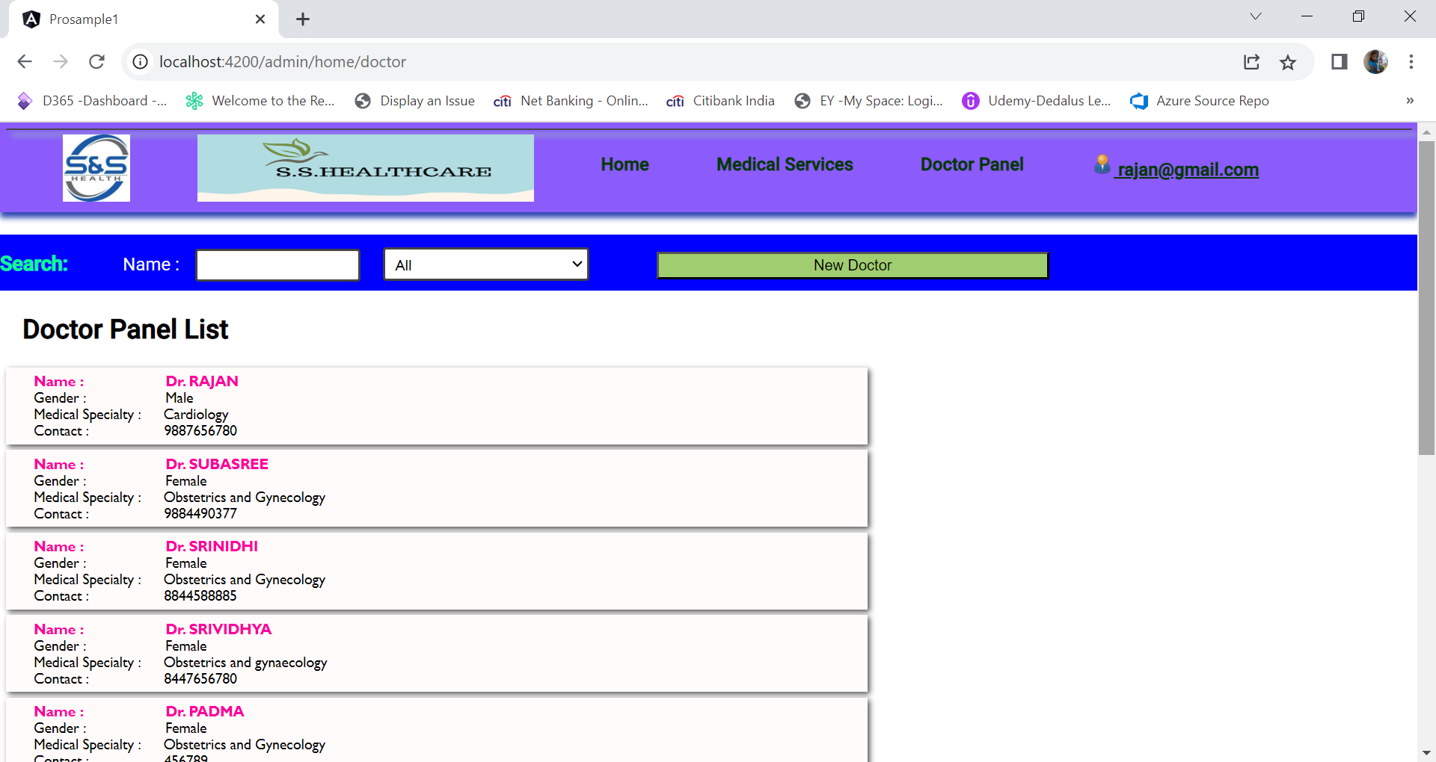

Search Panel



New Doctor button will be available for only administrator login workflow

Two parameter is passed in doctor filter pipe.

1. Partial / Full name of the doctor
2. Specialty of the doctor

## Doctor List Panel – Filter Based on Specialty

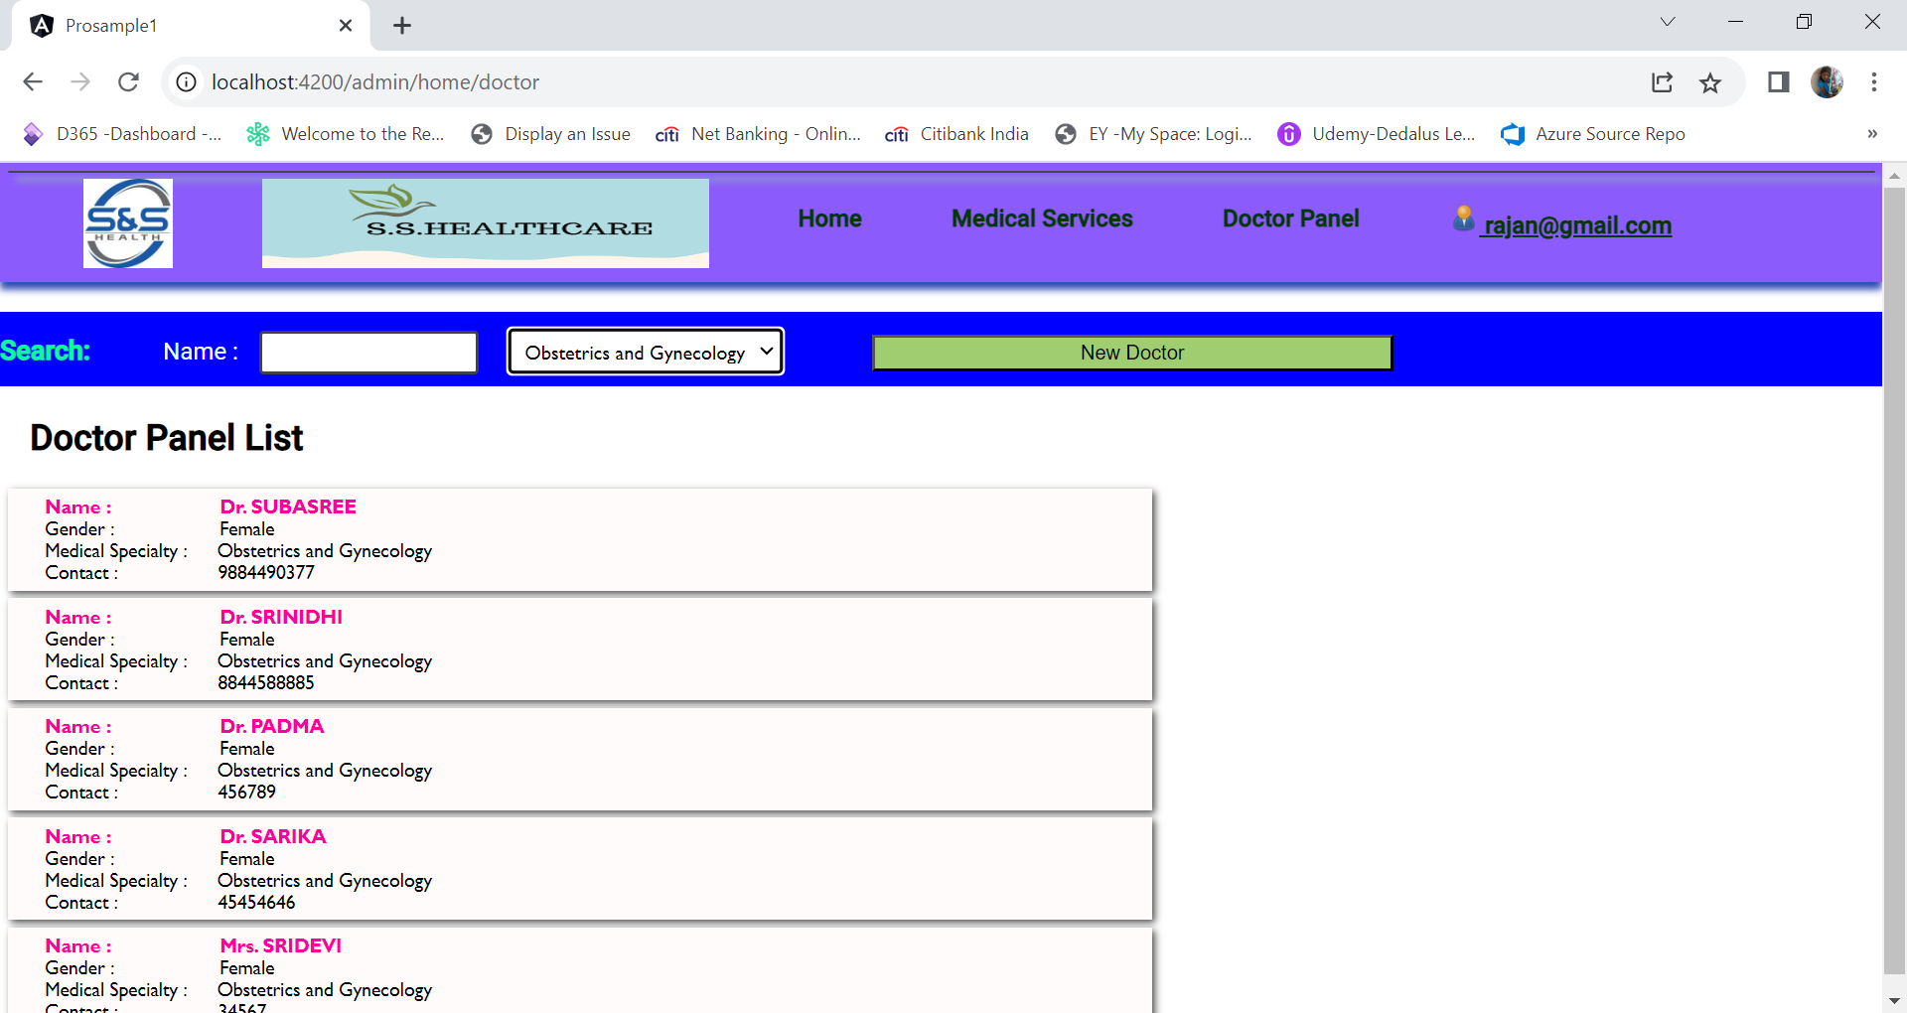

## Doctor List Panel – Filter Based on Specialty and Partial Name

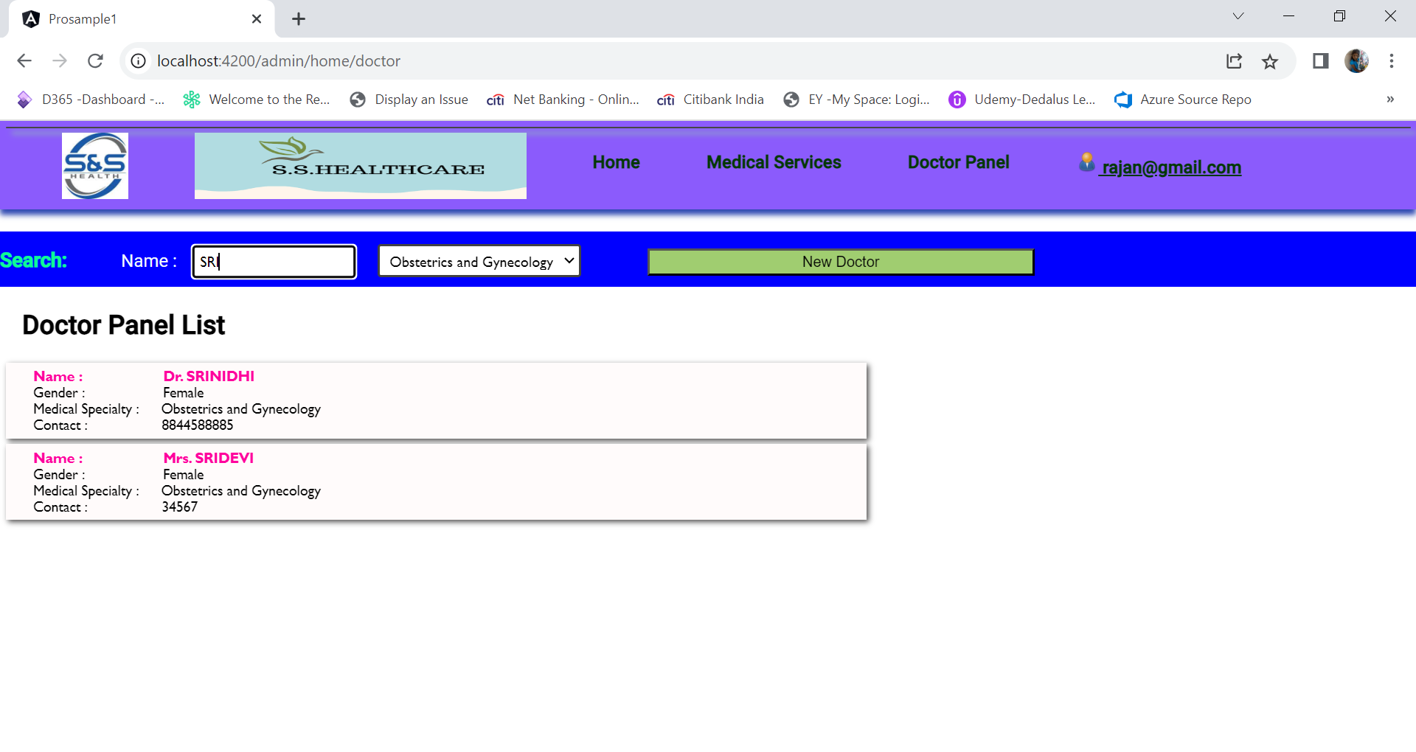

## New Doctor Creation

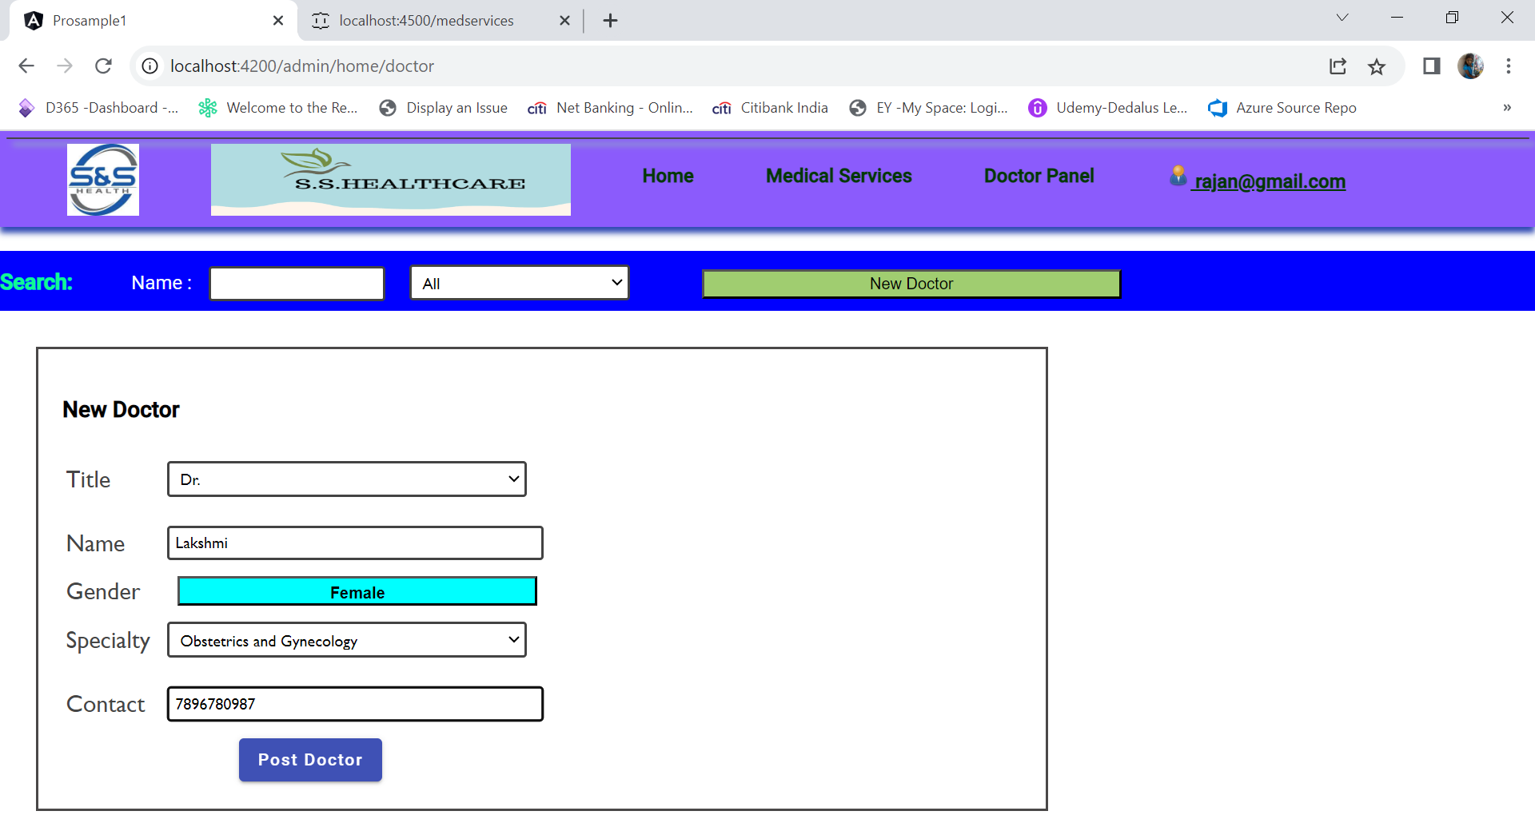

Click on Post Doctor

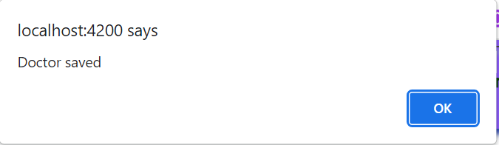

## New Doctor List

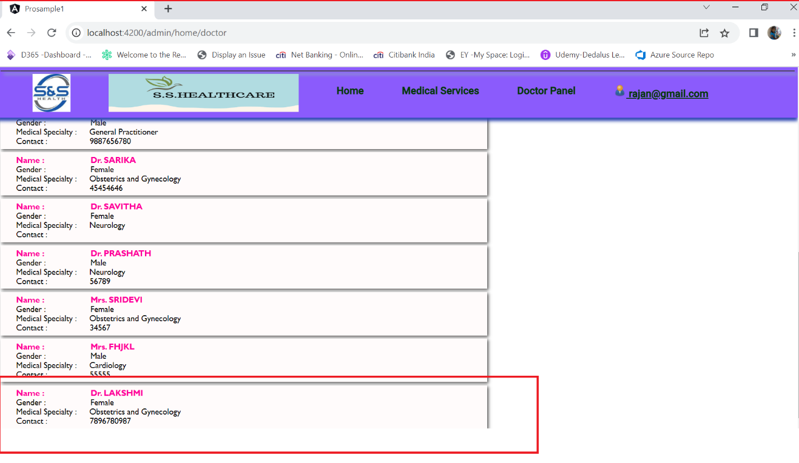

# User workflow.

## Login as User ([Suresh@gmail.com](mailto:Suresh@gmail.com))

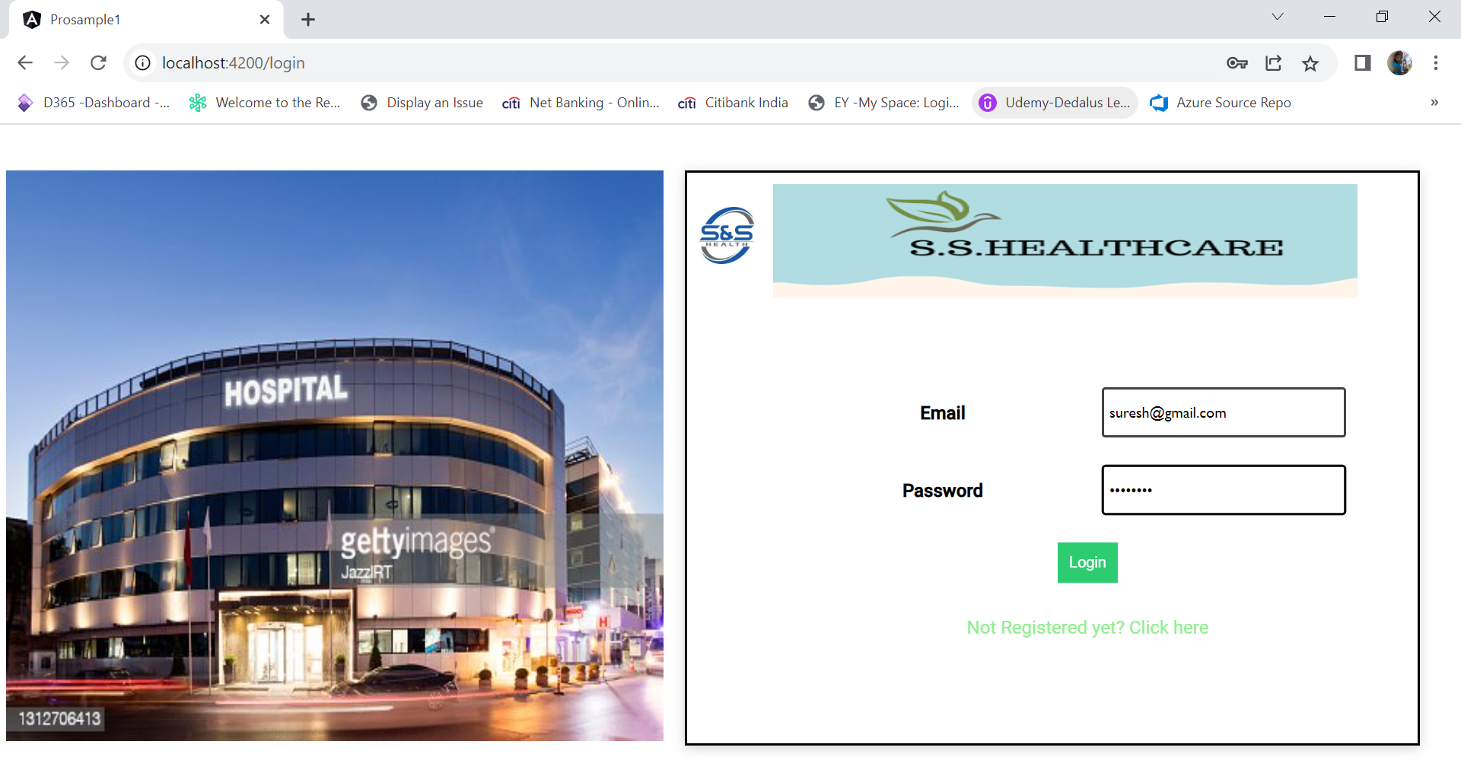

## 

## User Home screen

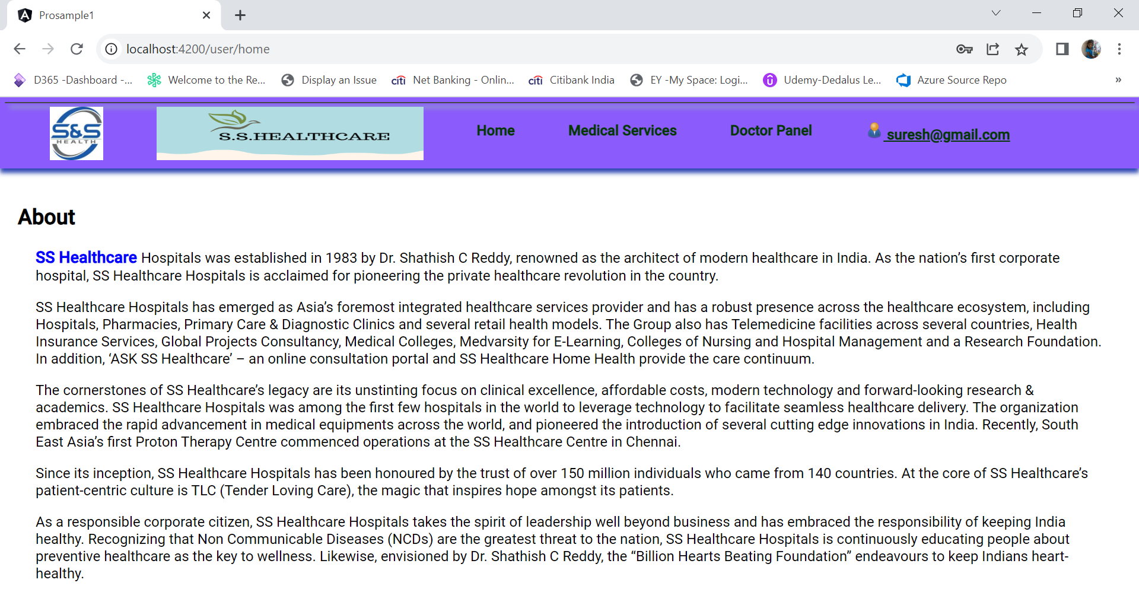

## User Medical service screen

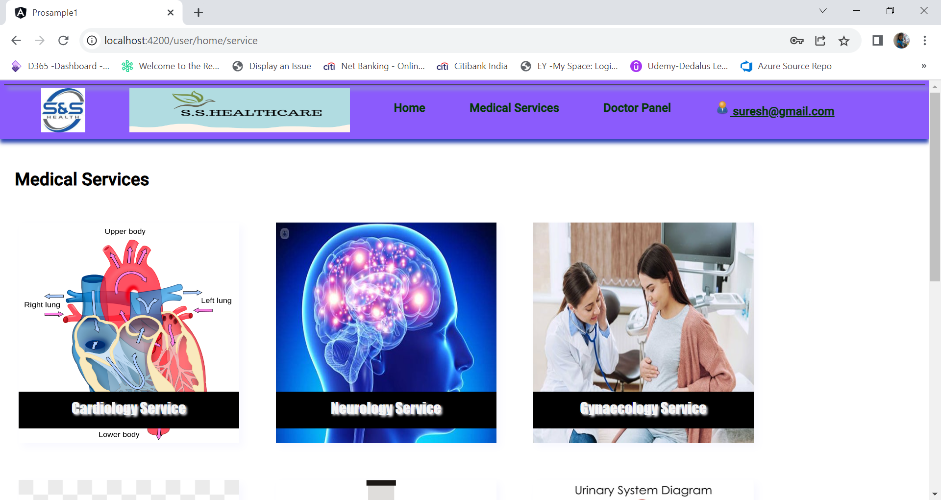

## User Medical service Detail screen

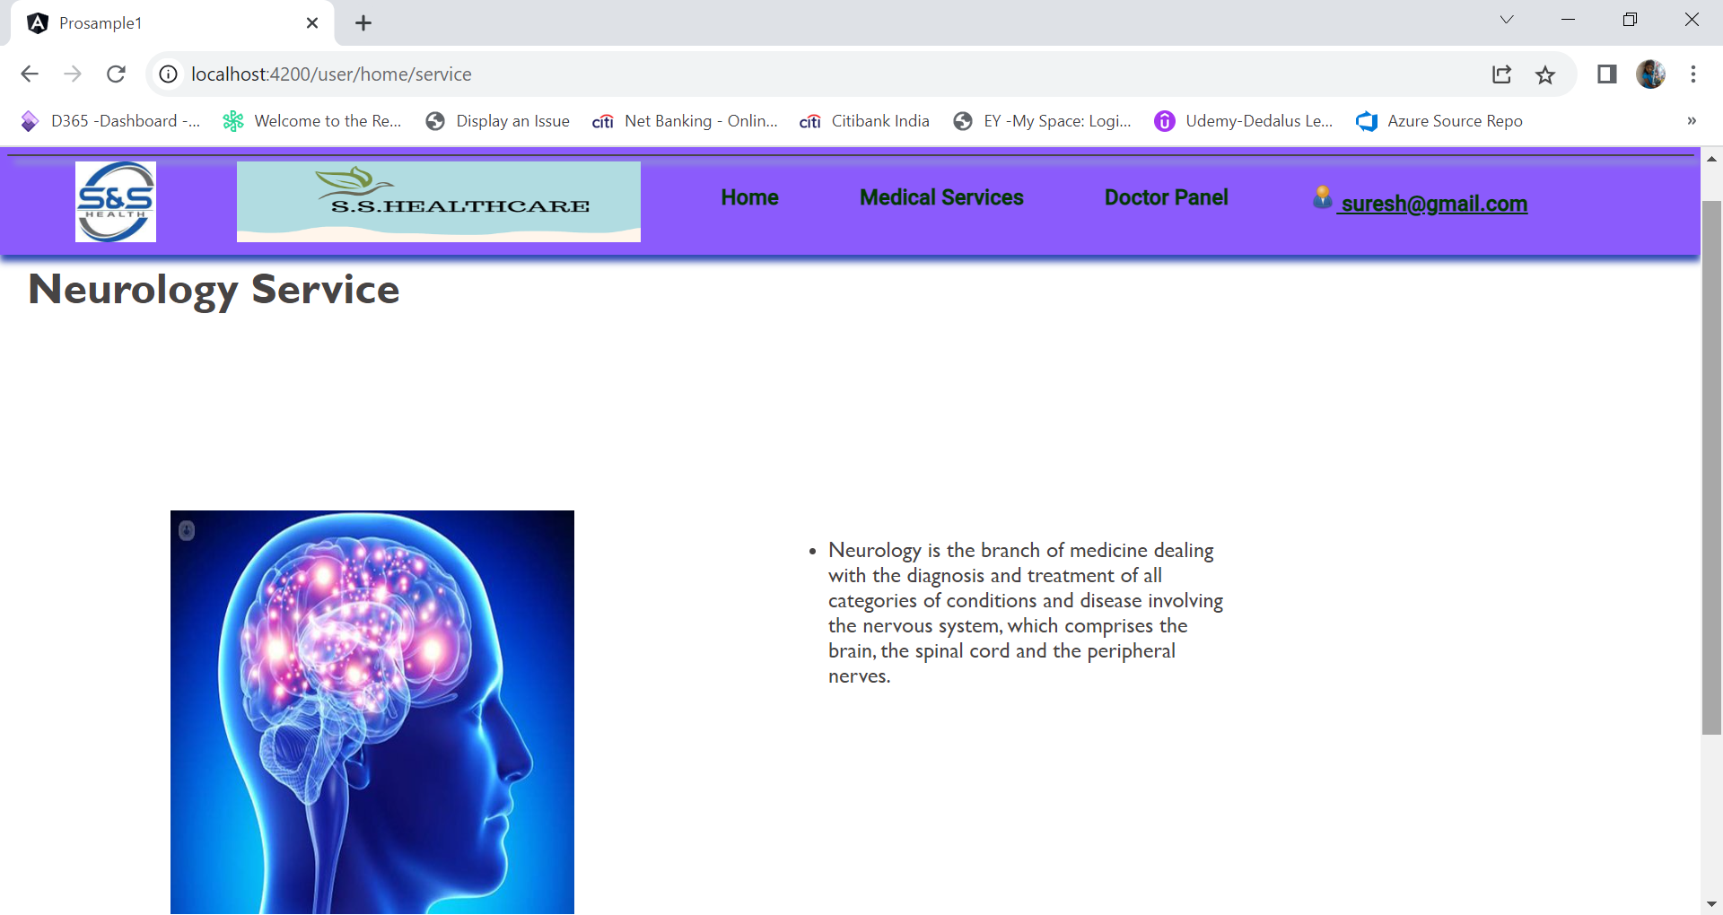

## User Doctor List panel

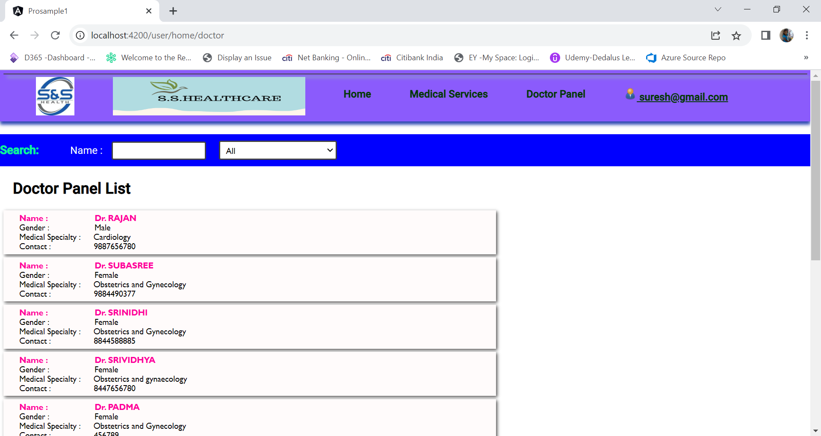

## User Doctor List panel – Search by specialty

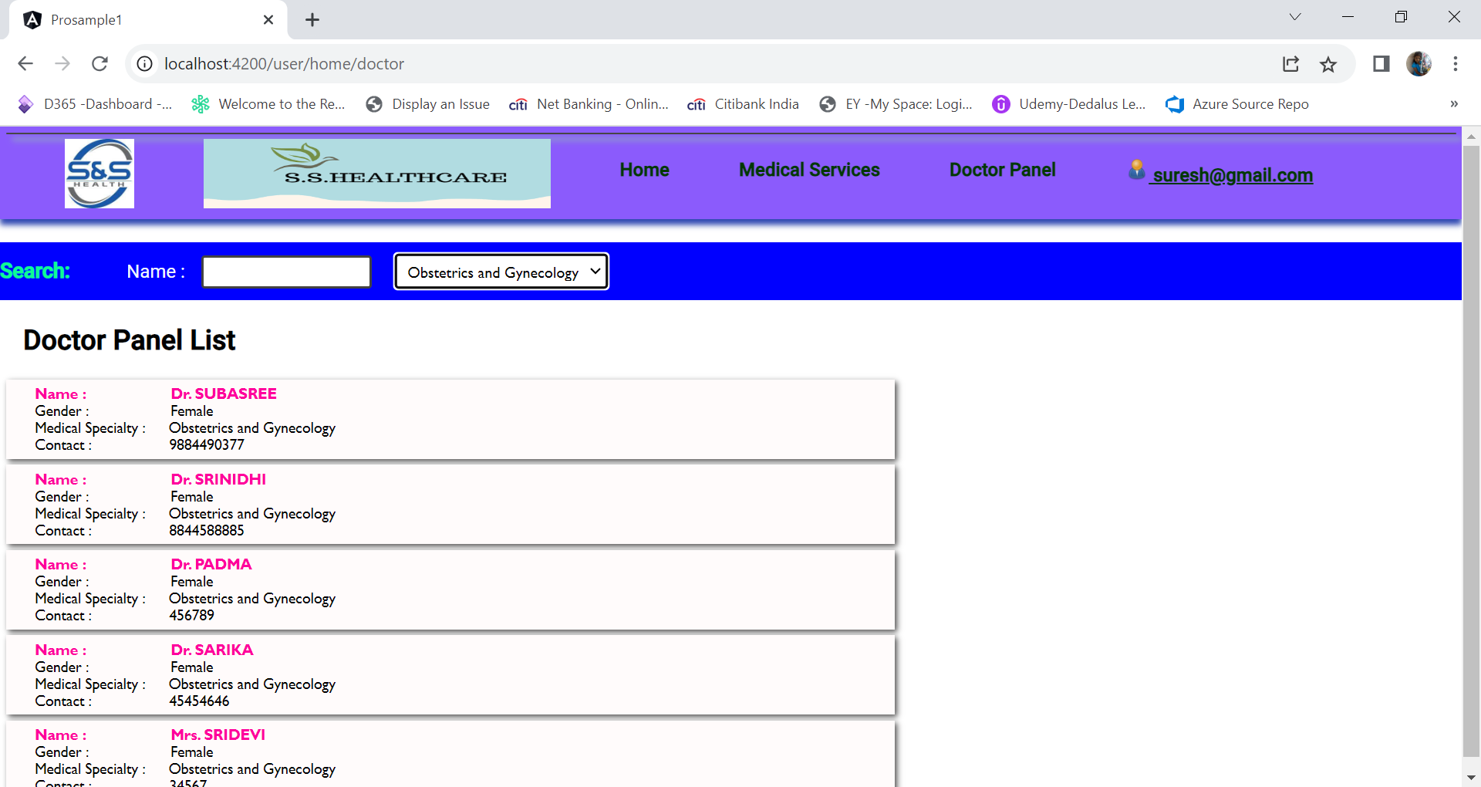

## 

## User Doctor List panel – Search by specialty and Partial doctor name

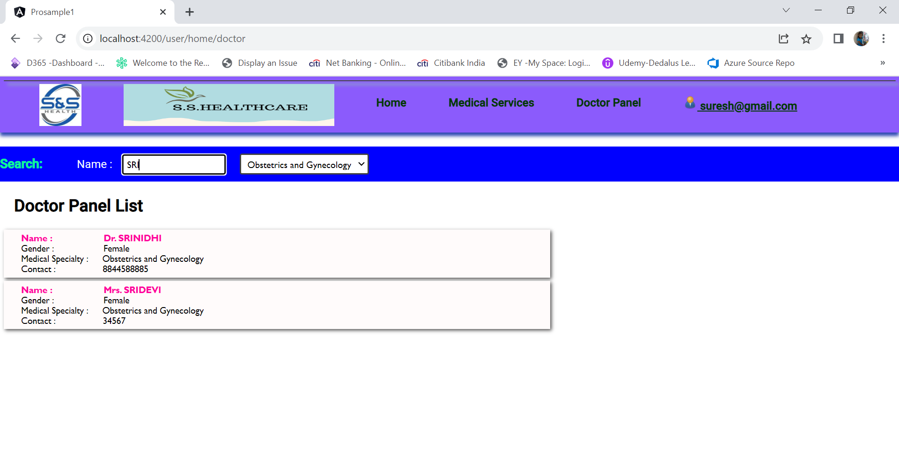

## User Logout

